IIFR – Academic Council

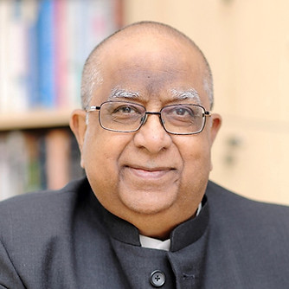

Prof. Rajendra Srivastava
https://in.linkedin.com/in/rajendra-srivastava-816643118
Prof. Rajendra Srivastava is a globally recognised leader in marketing strategy and innovation. He has served as Dean of the Indian School of Business and held senior roles at leading international institutions. His research in marketing metrics and brand management has had significant academic and industry impact. He also advises leading organisations on strategic transformation. Prof. Srivastava continues to shape the future of business education and strategy.
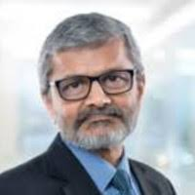
Prof. Uday B. Desai
https://in.linkedin.com/in/ubdesai
Prof. Uday B. Desai is a distinguished academician and the founding Director of IIT Hyderabad. He is Professor Emeritus in Electrical Engineering and holds multiple leadership roles across academic institutions. He serves as Chancellor of ICFAI Dehradun and Anurag University, and Vice-President of INAE. He has contributed extensively to policy and institutional governance through roles in DST and MeitY. Prof. Desai is widely respected for his contributions to engineering education and research.
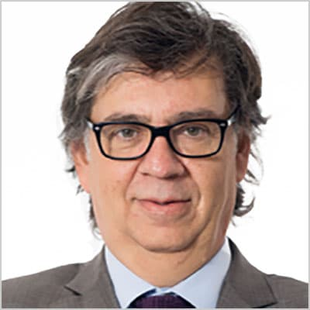

Alfons Sauquet
https://www.linkedin.com/in/alfons-sauquet-53871211/
Prof. Alfons Sauquet is associate director at EFMD Quality Services and Director of EDAF. He has earlier served as Global Dean of ESADE Business and Law School and Dean of the Business School. He has been a lecturer at HEC Paris, Erasmus Universiteit Rotterdam and Wharton School of Business. He has published articles and books on Learning and Innovation. He has served as elected member in the governing Board of the European Institute of Technology (EiT), the largest funded European initiative on education and research for Innovation.
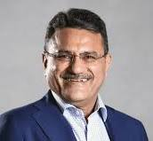
Manoj Kohli
https://www.linkedin.com/in/manoj-kohli-34948b108/
Manoj Kohli is a professional entrepreneur who loves shaping industry growth transformations. With 46 years of industrial experience, he is now the Chairman and Managing Partner in MK Knowledge LLP. Manoj is known for building admired brands, agile cultures, and high-performance leadership teams. He served as the country head of Soft Bank, CEO & MD of Airtel, and executive chairman of SB Energy. He is an independent director, a business advisor to many large companies and a coach to young entrepreneurs. He teaches leadership and strategy in the leading schools across the world.

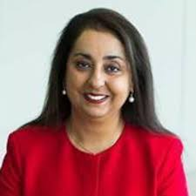
Prof. Baljit Sidhu
https://www.linkedin.com/in/baljit-sidhu-66870a8/
Baljit K Sidhu is the Professor of Accounting at the University of Sydney Business School. She serves on the Academic Advisory Panel of the Australian Accounting Standards Board, and has served on the AFAANZ Board, and as Director of the Centre for Research in Finance at the AGSM. Baljit is Joint Editor-in-Chief at Abacus, Deputy Editor at Accounting & Finance, and is the former Editor-in-Chief of the Australian Journal of Management (2010-2016). She has experience in corporate banking and has held appointments at leading universities in Australasia and visited extensively at international business schools (e.g., LSE, Rice, Rochester, Stanford) including teaching at the London Business School and the University of Michigan.

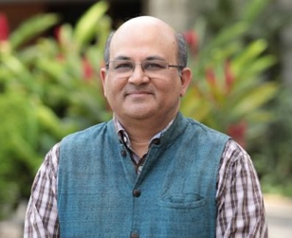
Prof. Rishikesha T. Krishnan
https://in.linkedin.com/in/rishikesha-krishnan-662601
Prof. Rishikesha T. Krishnan is Professor of Strategy at IIM Bangalore and a leading academic administrator. He has served as Director of IIM Indore and IIM Bangalore, shaping two of India’s premier institutions. His work focuses on innovation, strategy, and technology management. He is recognised for driving institutional transformation and academic excellence. Prof. Krishnan continues to influence management education through research and leadership.

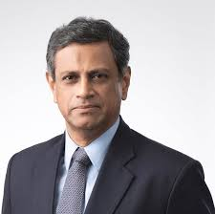
Mr.Nandu Nandkishore
https://ae.linkedin.com/in/nandu-nandkishore-7380a722
Mr. Nandkishore is a global C-suite leader with over three decades of experience across markets worldwide. He has held senior leadership roles at Nestlé, including Global CEO of Nestlé Nutrition. He is currently Professor of Practice at the Indian School of Business and engages actively in academia. Known for his expertise in marketing and strategy, he bridges industry and academic perspectives. He is also a frequent speaker at global platforms including the World Economic Forum

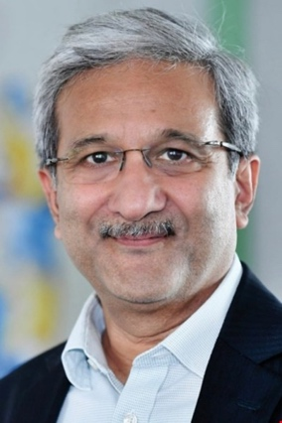
Prof. Ashley Braganza
https://www.linkedin.com/in/ashley-braganza/
Professor Braganza is the Chair in Business Transformation and former Dean of Brunel Business School. He is an internationally recognised subject matter expert for organisational transformation. He is a passionate believer in student employability with a strong network of global contacts. He has extensive board level experience in academic and commercial environments. He is the Founder and co-Director of Brunel’s interdisciplinary Research Centre for Artificial Intelligence.

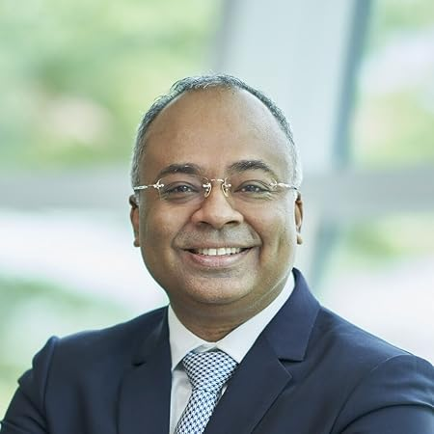
Prof. Gerry George
https://my.linkedin.com/in/gerry-george-a713505
Prof. Gerry George is Group Managing Director at International Medical University, Malaysia. He is a globally recognised scholar in entrepreneurship and innovation, with prior leadership roles at Singapore Management University and Imperial College Business School. He has also been associated with London Business School and leading global universities. His work bridges academia, policy, and impact investing. Prof. George continues to contribute to global entrepreneurship ecosystems and academic thought leadership.

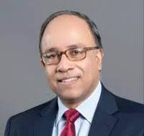
Dr. S. Ramakrishna Velamuri
https://in.linkedin.com/in/ramavelamuri
Dr. Rama Velamuri is a Professor specialising in entrepreneurship, business model innovation, and business ethics. He serves as Dean of the School of Management at Mahindra University. He has previously taught at CEIBS (Shanghai) and IESE Business School. His research is widely cited and includes award-winning case studies. Dr. Velamuri contributes significantly to advancing entrepreneurship education and research globally.
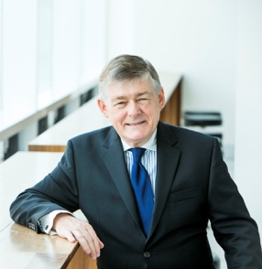
Prof. John Roberts
https://www.linkedin.com/in/john-roberts-b9823a21/

Prof. John Roberts is a Scientia Professor at the University of New South Wales. He is a Fellow of Fudan University, London Business School, and the Academy of Social Sciences in Australia. He is a highly acclaimed scholar in marketing science, recognised with the Buck Weaver Award. He also received the Sir Charles McGrath Award for lifetime achievement in marketing. Prof. Roberts founded the strategic consulting firm Marketing Insights. In 2023, he was appointed a Member of the Order of Australia

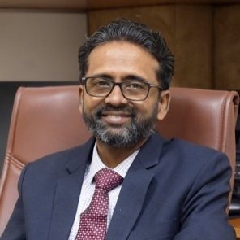
Prof. Arvind Sahay
https://in.linkedin.com/in/arvind-sahay-0944b02
Prof. Arvind Sahay is Director and Professor of Marketing and International Business at MDI Gurgaon. He previously served as a faculty member at IIM Ahmedabad and London Business School. With extensive experience in global academia, he brings deep expertise in marketing, strategy, and international business. His academic leadership spans research, teaching, and institutional development. Prof. Sahay is widely respected for his contributions to management education globally.

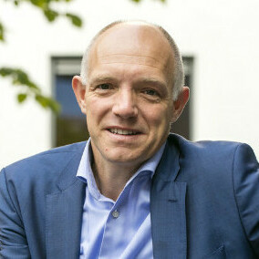
Dr.Koen Vandenbempt
https://www.linkedin.com/in/koenvandenbempt/

Prof. Koen Vandenbempt is professor of Strategic Management and Associate Dean for Internationalization. He is a former dean at the Faculty of Business and Economics, University of Antwerp. Koen serves on the EFMD programme accreditation board. He is a researcher, advisor and management trainer in the field of strategy formation and strategic marketing. His expertise includes business model innovation and organizational mindfulness.
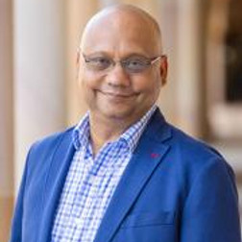
Prof. Ashish Sinha
https://au.linkedin.com/in/ashish-sinha-7a021522
Prof. Ashish Sinha is Professor of Marketing at UQ Business School and Visiting Professor at the Indian School of Business. He has held several senior academic leadership roles, including Academic Dean of Executive Education at ISB. His career spans academia and industry, including leadership roles in analytics at IRI, Chicago. His expertise lies in marketing, analytics, and research. Prof. Sinha brings a strong blend of academic rigour and industry insight.

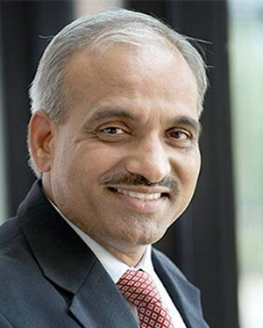
Dr. Bhimaraya Metri
https://in.linkedin.com/in/bhimaraya-metri-26b42137
Dr. Bhimaraya Metri is the Director of IIM Nagpur and a distinguished academic leader in management education. He is widely recognised for his contributions as a teacher, researcher, and institutional builder. Over his career, he has held key leadership roles across premier academic institutions and industry. His work focuses on strengthening academic excellence and governance in higher education. Dr. Metri continues to shape management education through his strategic vision and leadership.

